|  |
| --- |
| **it SUPPORT INSTRUCTION** |

**how to connect a printer**

VERSION 1.0

2024

INTRODUCTORY PROVISIONS

GOALS

This instruction defines the procedure for an employee to follow providing advice on connecting printer.

TASKS

The main objectives of the instruction are:

* description of the steps to take when you need to connect a printer.

PERIOD OF VALIDITY AND PROCEDURE FOR MAKING CHANGES

Changes to the instruction are made when new settings appear in the SOFTWARE, as well as when information on current settings is updated.

After you install a printer, you must also ensure that it’s connected to your computer. You can add or connect to a printer in Excel using the File and Print options. Once the device has been added, you can print either within the Print option or by using the keyboard shortcut, Ctrl + P.

**Note:**First, be sure that your printer is installed using the printer’s manufacturer instructions. To find out how to install a printer either locally or in a network, see Install a printer.

**IN THIS ARTICLE:**

* Connect to a printer
* Add a new printer
* Set your default printer

**CONNECT TO A PRINTER**

1. In Excel, click **File** > **Print**.

**Tip:**You can also use the keyboard shortcut, Ctrl + P.

1. Click the **Printer** drop-down arrow, and select the printer you want to connect to.

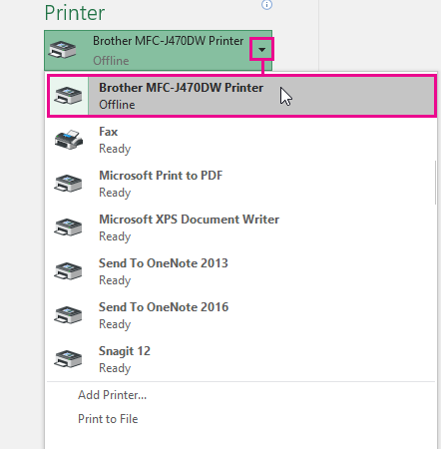

**ADD A NEW PRINTER**

If the printer you need to connect to is not listed, you need to add it.

1. In Excel, click **File** > **Print**.
2. Click the **Printer** drop-down menu, and click **Add Printer**.

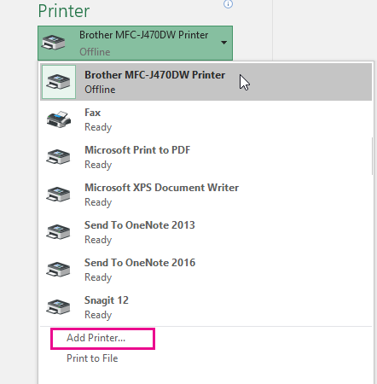

1. In the**Find Printers** dialog box, type the name of your printer in the **Name** text box. Click **Find Now** to search.

**Tip:**To search for all printers, leave the **Name** text box empty, and click**Find Now**. You can also type part of the printer name to search for it.

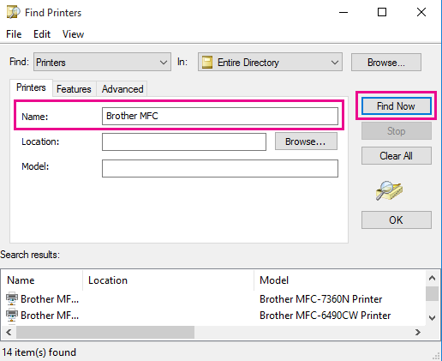

1. In the search results, select the printer, and click **OK**. This printer is connected, and your Excel document will print on this printer.

**SET YOUR DEFAULT PRINTER**

For quicker printing, set a printer as the default printer. This process is different slightly among Windows 7, Windows 8, and Windows 10.

1. Open the **Devices and Printers** dialog box.

In Windows 10, in the **Search** box, type **Devices and Printers**, and then click **Devices and Printers**.

In Windows 8, go to the start screen, type **Devices and Printers**, then click **Devices and Printers**.

In Windows 7, click **Start** > **Devices and Printers**.

**Note:**You can also access this through Control Panel. In Control Panel (category view), in the **Hardware and Sound** category, click **View devices and printers**.

1. Under **Printers** right-click the printer you want as your default printer, and click **Set as default printer**.

**Note:**This might also be listed under **Printers and Faxes**, depending your version of Windows.